Pre-K Supply 2020

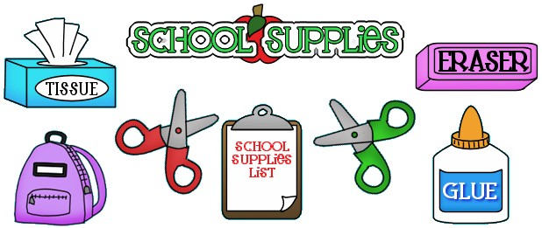

1. Bookbag (cloth or plastic)
2. Facemasks (required)
3. 4 Elmer’s Glue Sticks (Large)
4. Pencil Box
5. 2 pocket folders (plastic)
6. Box of crayons, 8 count
7. Seat cushion (small) for circle time. Can be found at Walmart, Target or Dollar Tree.
8. 1 Lysol Disinfesting Wipes
9. 1 Box of Puffs Facial Tissues
10. 1 pack of facial wipes
11. 2 Boxes of Hefty or Ziploc bags quart, gallon, 2-gallon size
12. 1 Foam/Gel Hand Sanitizer
13. Blanket (for naptime) small enough to place in grocery size bag for storage.
14. A change of clothes which include also (underwear, socks) to be left in book bag.

Thank You, for your support!!! ☺ 

Mrs. Pinkney and Mrs. Rowe Pre-K Teachers